Requirements:
- Turnaround sheets
  - Frontal (T-pose)
  - left lateral (don’t draw the arm just the body here)
  - back (T-pose)
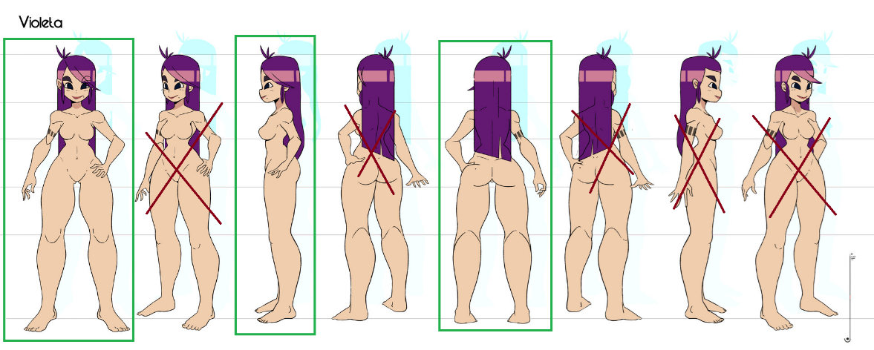
- Characters
  - Tracey
  - Scott
  - Holy
  - Vernon

There must be 2 versions of the turnaround sheet:
  - Clothed version of the character.
  - The same clothed version, but with a line guide of the shape of the body of the character (especially if they have baggy or clothes that are bigger than the naked body of the character, like with the case of Holly’s skirt), check the next image for an example:
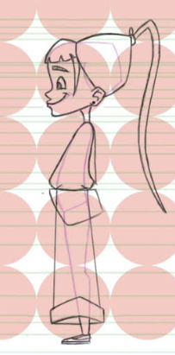
- Facial expression sheet: I’m not going to rig and animate the faces of characters; I’m going for the old school style of swapping 2d textures. Since these are stylized characters, this works great. You can check the first 20 seconds of this video to get an idea, also the next image is an example of it:
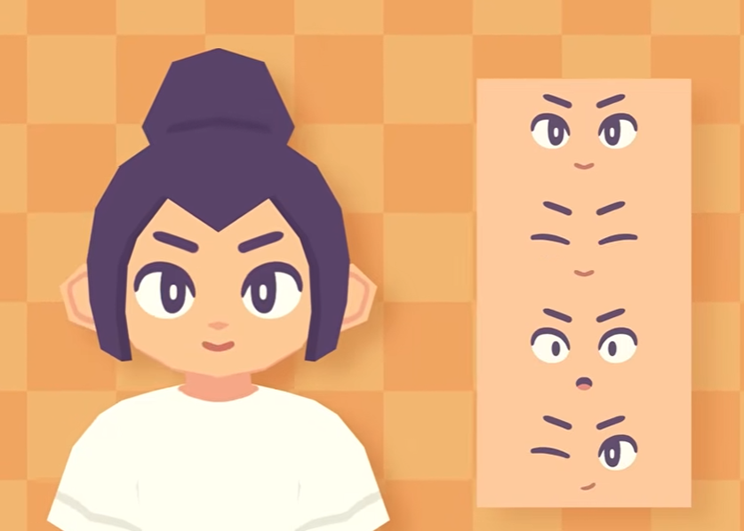

List of expressions:

Holly:  - Scared, terrified  - Concern-worried  - Shock  - Surprise  - Confused  - Sadness  - Neutral  - Melancholic  - Smiling  - empathic | Vernon:  - Sleeping  - Coughing (tuberculosis)  - Pain  - Yelling  - Angry  - Neutral  - Tired | Scott:  - Unconscious  - Weak (wounded)  - Pain  - Little smile (pain)  - High (on drugs, tired eyes, smiling)  - Shock  - scared
Extras:  - Blinking eyes  - Closed mouth 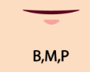  - O mouth   - L mouth 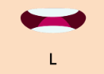 | Extras:  - Blinking eyes  - Closed mouth   - O mouth   L mouth  | Extras:  - Blinking eyes  - Closed mouth   - O mouth   L mouth 

- Friend group sketch.
For this requirement, please have in mind the characters profiles document, and specially Shannon’s profile.
In the story of the demo, Shannon makes a drawing sketch of her 6 friends (Tracey, William, Holly, Rylee, Robert, Scott). She draws them enjoying their camping trip. Shannon is naturally absent from the sketch as she is the observer.
The base is the friends around a bonfire, but how you do it: I give you complete freedom on how you want to do this, the composition and poses of each character are up to you. Also, it’s a sketch, so don’t worry about quality or a final render, it’s a fast gestural sketch of Shannon’s perspective, but with enough detail to tell who is who, and if possible, their personalities.
I’m sorry this is the most abstract task, and for this I give you freedom on how you want to do it. And my eternal gratitude.
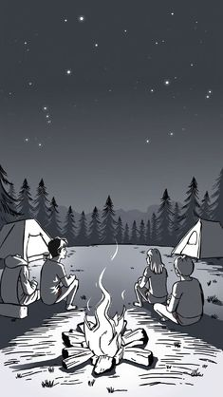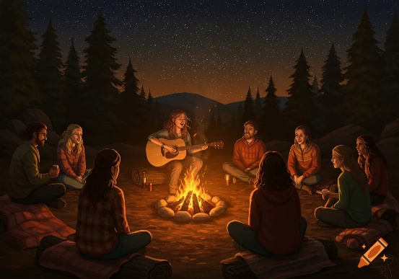
Don’t show any camping tents, if you want, just sketch people, don’t worry about detailing too much about the environment, maybe just the bonfire, the tree line and the horizon, but the focus here is the characters.

